Week 14

# Q) Create table and insert at least five employee details.

Steps:

1. Create new database:  
   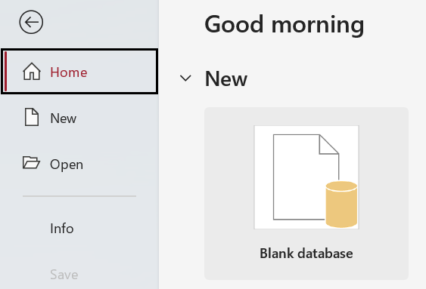
2. Go to “Create” tab, then “Query Design” and then click on “SQL View”  
   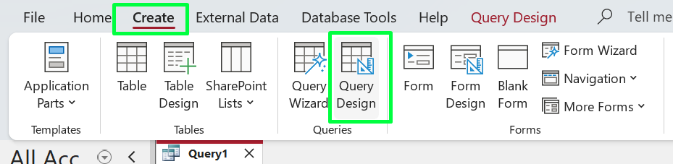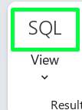
3. To create the table, use this query:  
   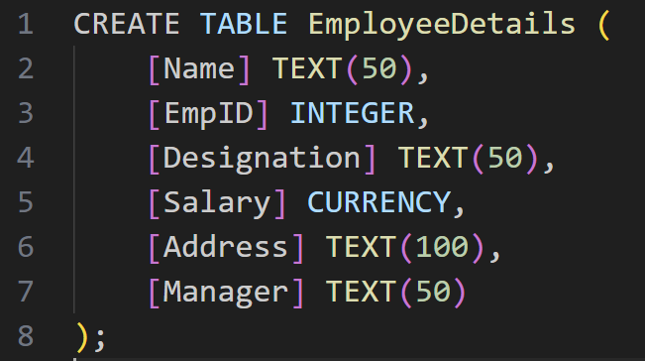
4. 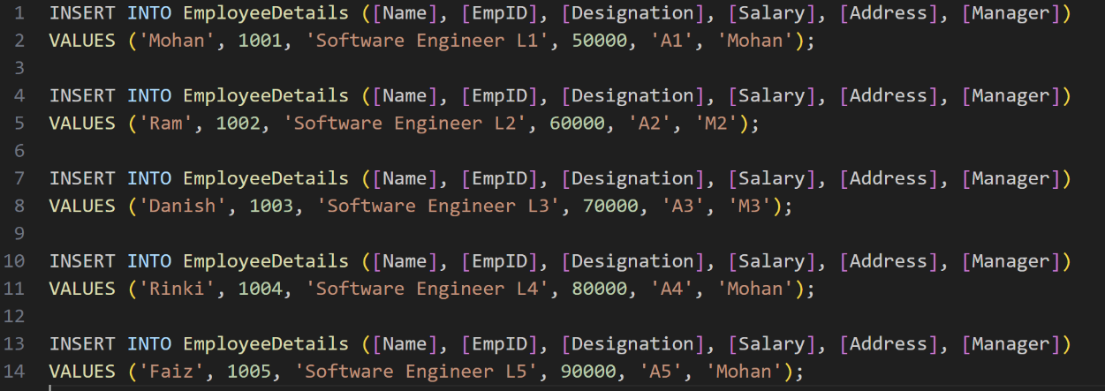To add data, use INSERT INTO queries, one at a time.
5. To view data in table, go to “Home” Tab, then click on “Refresh All”  
   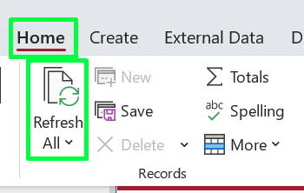
6. Result:  
   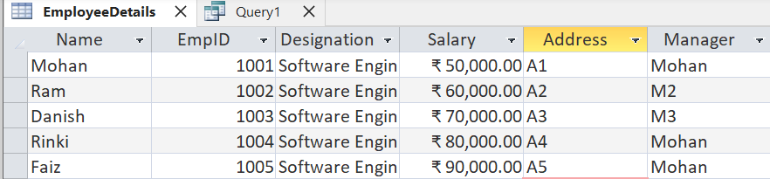

# Q) Write SQL queries for the following:

1. Display all records of employee details containing Emp-id =’1001’.
2. 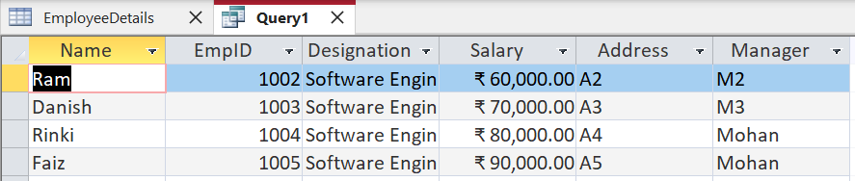Display all records of employee details having salary greater than the minimum manager salary.  
     
   Here, the minimum salary under any particular manager is ₹50,000.
3. 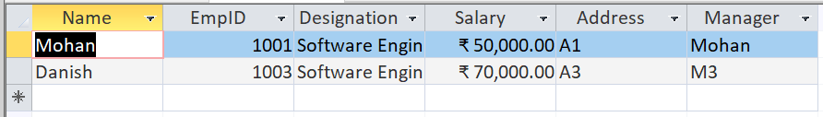Display all records of employee whose name contains ‘an’.
4. 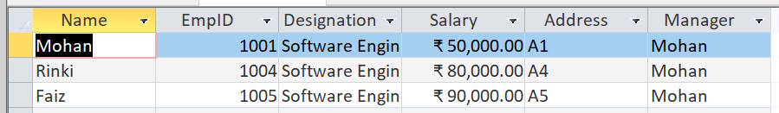Display all records of employee details whose manager =’Mohan’.

# Q) Create table and insert employee detail (Emp-id , designation ,salary, address, Contact no etc.)

1. Create table using query:  
   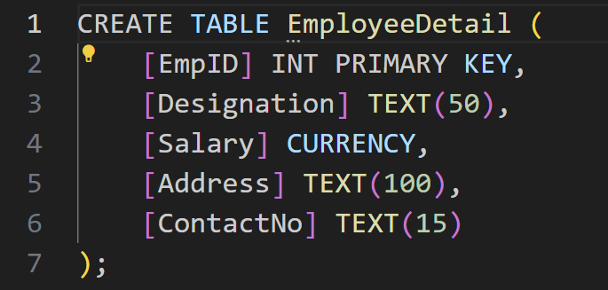
2. 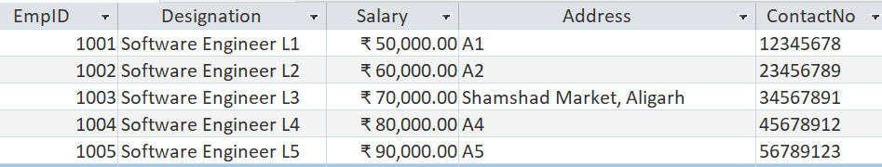Using INSERT INTO queries:  
   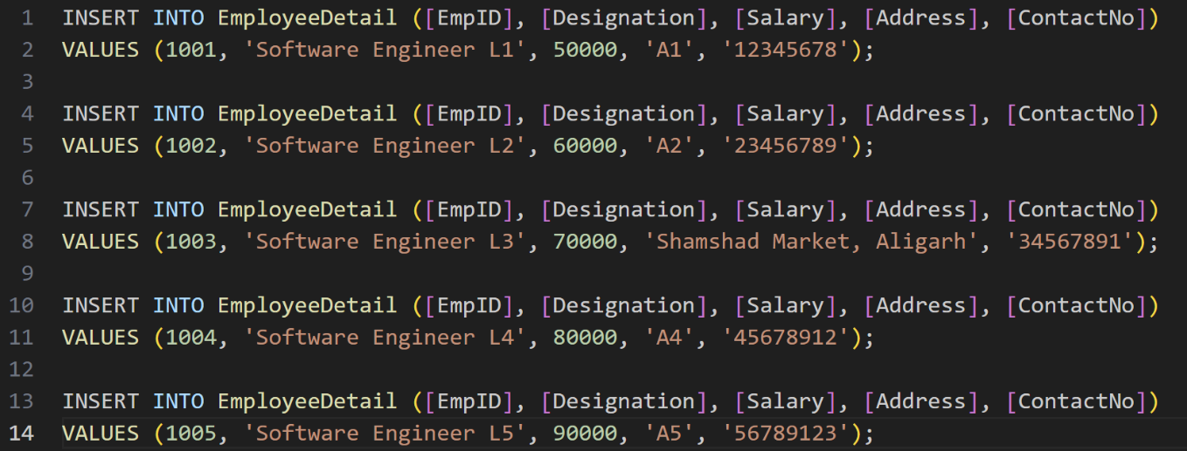
3. Displaying contact numbers of employees:  
   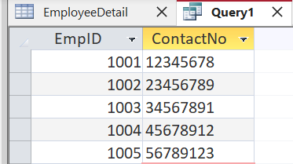
4. 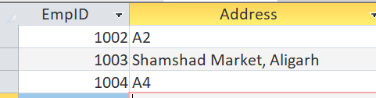List the address of employee whose Id between 1002 to 1004.

5. Make a report on the employee whose address is “Shamshad market, Aligarh”.



